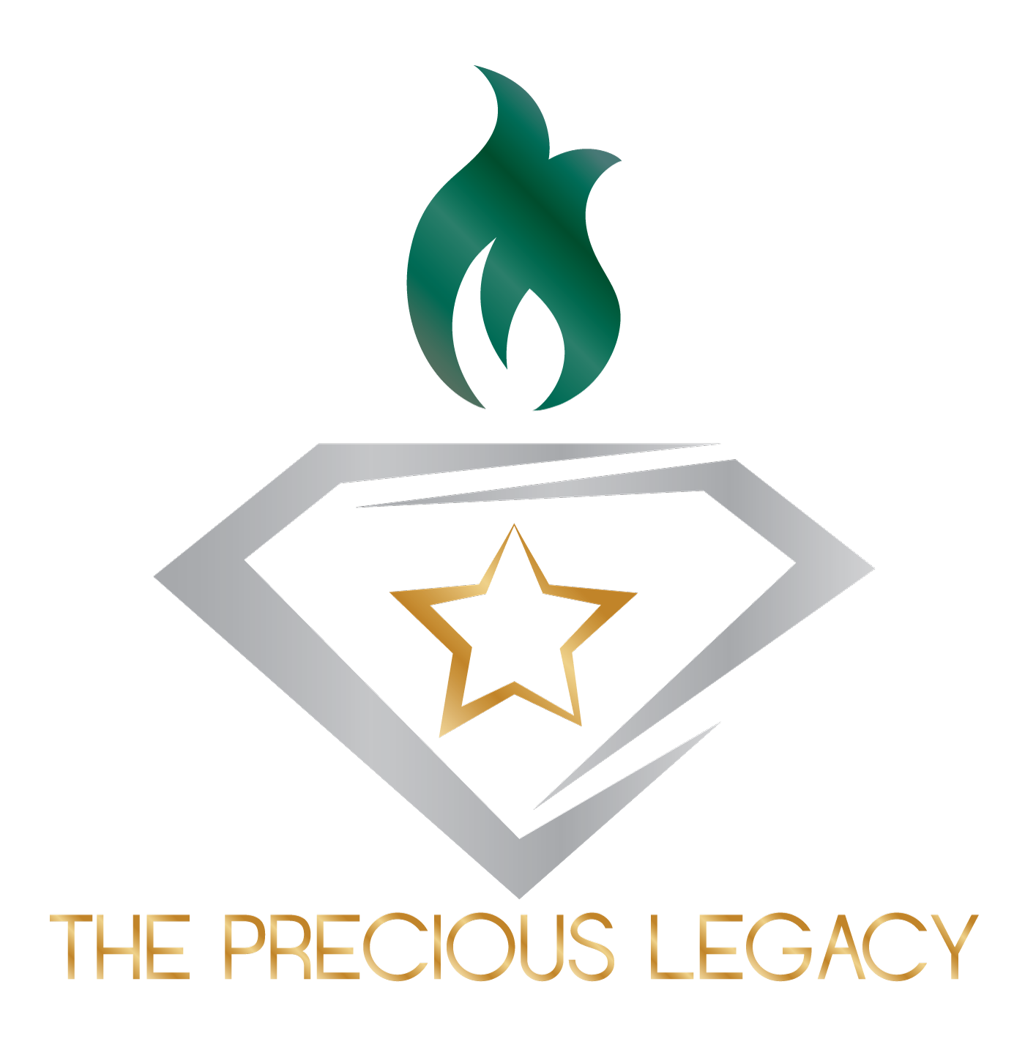

Welcome to The Precious Legacy! We hope to provide each of our attendees with the most relaxing and fun experience possible throughout their stay. Our priority here at TPL is to provide a chance to meet other survivors and build family-like relationships that will help in their personal walk through grief. In our greatest attempt to maintain the integrity of a young adult retreat, we have established this Code of Conduct for all retreat guests, facilitators, volunteers, and coordinators.

- Illegal substances and ANY kind are absolutely prohibited throughout the duration of the retreat.

- We want ALL our guests to have an enjoyable experience. So, in keeping with our values and respect to our underaged attendees, the retreat is alcohol free, and no alcohol will be on the premises. Attendees of drinking age may order an alcoholic beverage, at their own cost, during our final dinner out in town, but EXCESSIVE drinking will not be tolerated. Please remember that we represent the face of The Precious Legacy to the community, donators, and to our volunteers.

- Vulgar, offensive, or abusive language will absolutely not be tolerated.

- Altercations (verbal or physical) between guests, facilitators, volunteers, and/or coordinators will not be tolerated and will be grounds for immediate removal.

- These are Coed retreats, attendees will be expected to respect personal spaces and refrain from sexual interactions.

