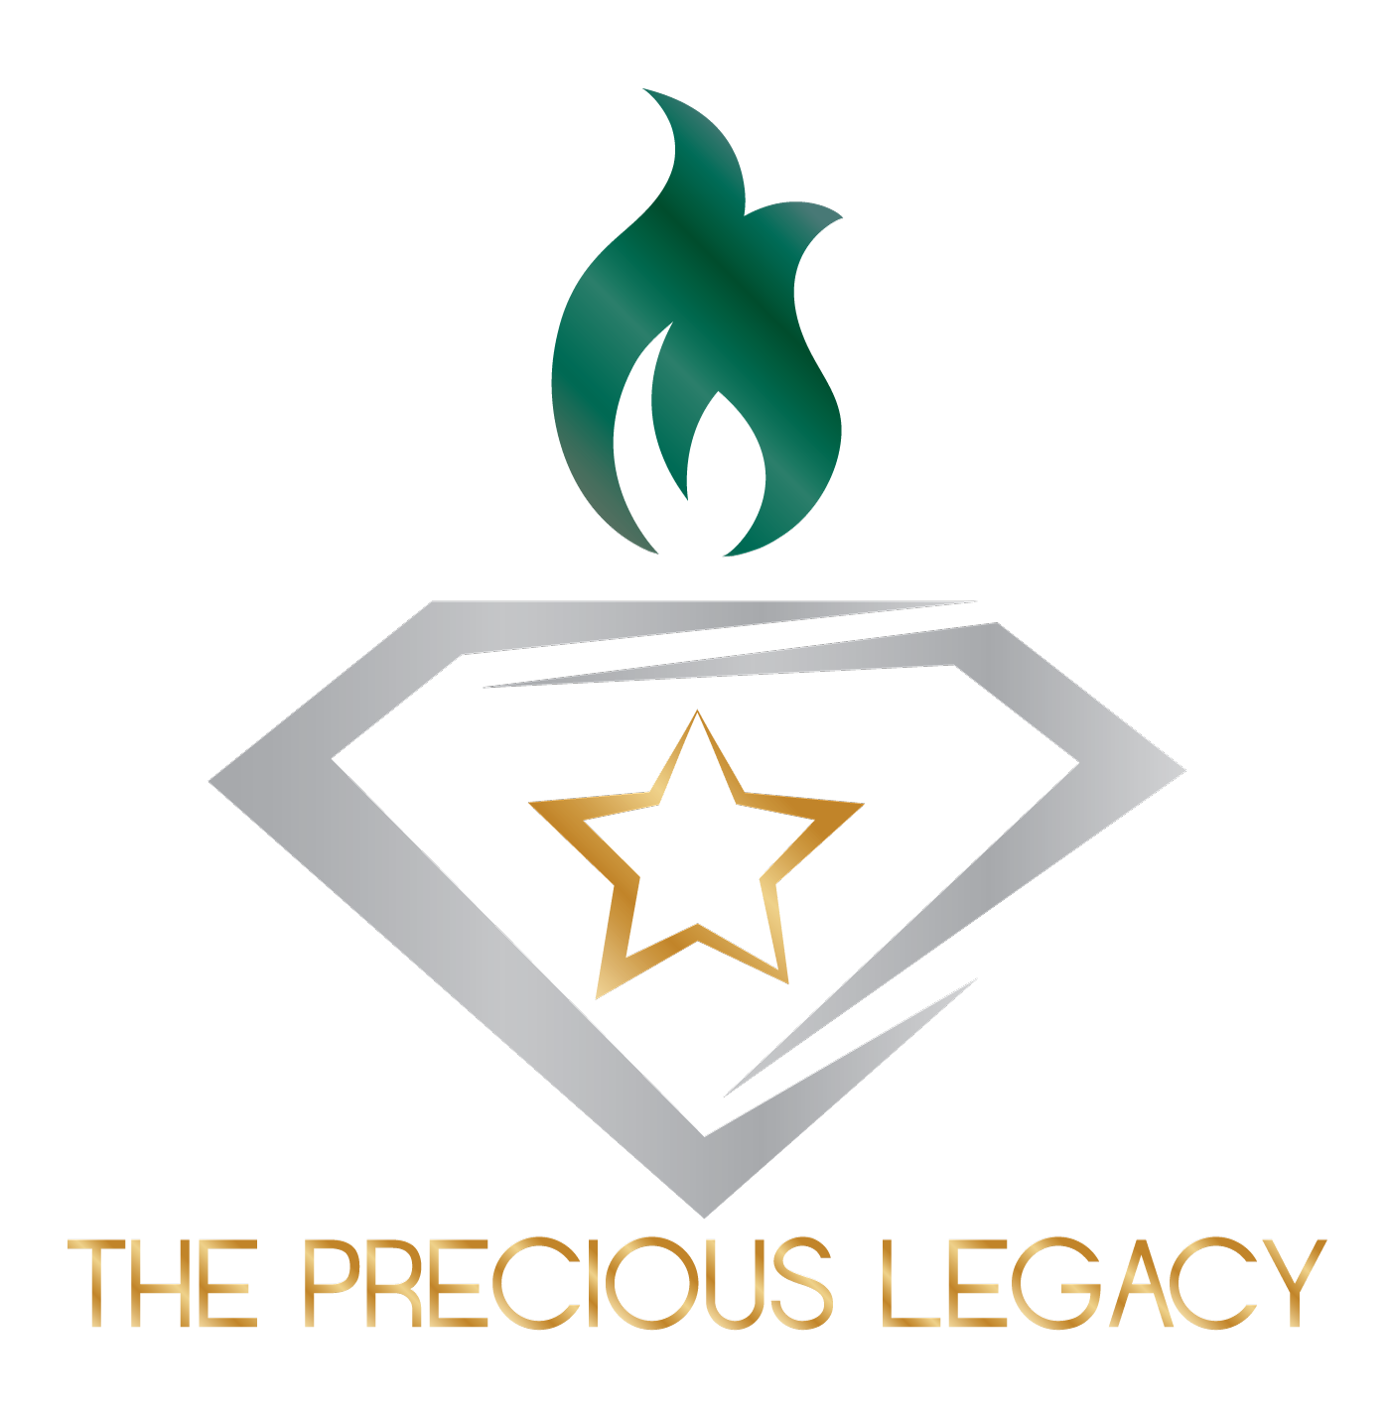

Release, Waiver, & Indemnification Agreement

I, _____________________________________, understand that The Precious Legacy’s goal is to provide an opportunity to relax and spend time with those that have experienced similar tragedies, helping them through their healing process.

Yes/No (Circle One): I give permission for photographs to be used in future marketing material, such as the website and printed brochures, and/or media relation efforts by The Precious Legacy.

In consideration of being granted permission by The Precious Legacy to attend the retreat, I, for myself, my heirs, personal representatives, and assigns, hereby release, waive, and discharge The Precious Legacy, its agents, employees, Board of Directors, officers, volunteers, successors, and assigns from all liabilities, claims, demands, causes of action, and judgments, which I ever had, now have, or may ever have against The Precious Legacy in any way relating to or arising at any time out of my participation in a retreat or other program facilitated by The Precious Legacy , whether located on a permeant premises or not.

To the greatest extent permitted by law, I agree to indemnify and hold harmless The Precious Legacy, its agents, employees, Board of Directors, officers, volunteers, successors, and assigns from and against any and all losses, damages, costs (including reasonable attorney fees), liabilities, claims, demands, causes of action, and judgments whatsoever of every name and nature, both in law and equity in any way relating to or arising at any time out of my participation in a retreat or other program facilitated by The Precious Legacy.

I, the undersigned, have read this agreement and understand all of its terms.

Survivor Signature and Date

